**פרויקט מאגר שיתופי לשיעורים - דוד ילין**

בניית מאגר מערכי שיעורים לסטודנטים להוראה בדוד ילין.  
המטרה היא ליצור פלטפורמה להעלאה ושיתוף מערכי שיעור.  
ברצוננו לבנות אתר נגיש וקל לשימוש, בו ניתנת האפשרות לחיפוש מערכי שיעור לפי מילות מפתח וסינון לפי תחומי הוראה.  
המערכת תאפשר לסטודנטים להתחבר לאזור האישי,להעלות מערכי שיעור חדשים, לדרג ולתת משובים על מערכים קיימים, והוספת מערכים נבחרים לרשימת המועדפים.

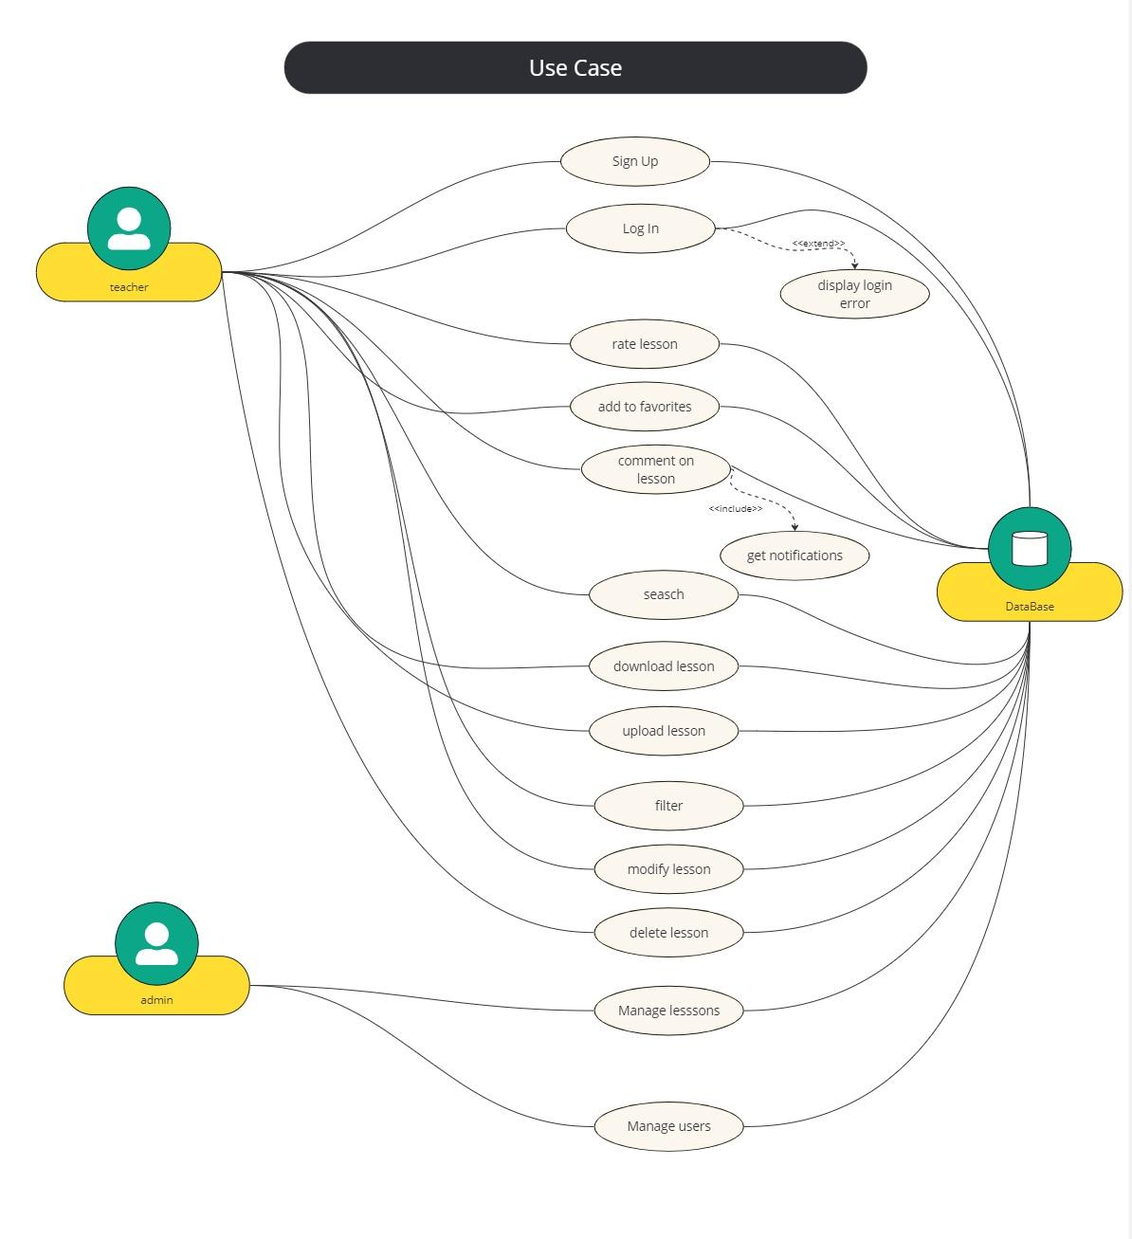

| **פונקציונלי** | **לא פונקציונלי** |
| --- | --- |
| העלאת מערכי שיעור חדשים | תמיכה ב-200 איש |
| סינון התוכן (לפי מקצועות, כיתות וכו'..) | ממשק קל לתפעול לטכנופובים(מעט פעולות/לחיצות לכל שלב) - אחריות של מאי |
| התכנים מוצגים רק למשתמשים רשומים | זמן תגובה קצר (3 שניות) |
| חיפוש שיעורים |  |
| דירוג שיעורים |  |
| הוספת שיעור למועדפים |  |
|  | מה לתקן? |

**Gantt Graph sketch - critical path**

1. **Project Start Date**: One week from today

2. **Project End Date**: July 26 of this year

1. **Phase 1: Requirements Gathering and Analysis**

- Duration: 1 week

- Activities:

- Gathering requirements

- Defining use cases

- Start Date: One week from today

- End Date: One week after start date

2. **Phase 2: Design**

- Duration: 2 weeks

- Activities:

- Designing the system architecture

- UI/UX design

- Start Date: Immediately after Phase 1

- End Date: Two weeks after start date

3. **Phase 3: Development**

- Duration: 6 weeks

- Activities:

- Front-end development

- Back-end development

- Database setup

- Start Date: Immediately after Phase 2

- End Date: Eight weeks after start date

4. **Phase 4: Testing**

- Duration: 2 weeks

- Activities:

- Integration testing

- User acceptance testing

- Start Date: Immediately after Phase 3

- End Date: Ten weeks after start date

5. **Phase 5: Deployment and Go-Live**

- Duration: 1 week

- Activities:

- Deployment to production

- Go-live

- Start Date: Immediately after Phase 4

- End Date: Eleven weeks after start date

6. **Phase 6: Post-Deployment Review and Maintenance**

- Duration: Ongoing after go-live

- Activities:

- Monitoring system performance

- User feedback collection

- Issue resolution and system updates

### Key Milestones

- **M1: Completion of Requirements Analysis**

- **M2: Design Freeze**

- **M3: Development Completion**

- **M4: Testing Completion**

- **M5: Deployment**

This structure will help ensure that your project is well-organized and milestones are clearly defined. To visualize this timeline, you could use tools like Microsoft Project, GanttProject, or online tools like Trello and Asana that support Gantt chart functionalities. These tools allow you to set the start and end dates, dependencies, and track the progress of each task visually.

**### Web Application Sketch Outline - V1**

### Home Page

- **Navigation Bar**: Includes links to Home, Browse Lessons, My Favorites, and Profile.

- **Search Bar**: Located prominently at the top to search lessons.

- **Main Area**: Featured lessons or newly added lessons are displayed here.

- **Login/Signup Button**: If the user is not logged in.

### Lesson Browse Page

- **Filter Options**: Side panel with options to filter lessons by category, rating, and more.

- **Search Results**: Display area for lessons that match the search and filter criteria.

- **Lesson Cards**: Small previews of lessons showing title, brief description, and a thumbnail.

### Lesson Detail Page

- **Video/Content Area**: Where the lesson content is displayed.

- **Comment Section**: Below or beside the lesson for users to post and view comments.

- **Add to Favorites**: A button to add the lesson to the user’s favorites.

- **Rating**: Options to rate the lesson.

### User Profile Page

- **User Details**: Username, profile photo, and bio.

- **My Uploaded Lessons**: List or grid of lessons the user has uploaded with options to edit or delete them.

- **My Favorites**: List or grid of favorite lessons the user has saved.

### Admin Panel (for administrators)

- **User Management**: List of users with options to edit roles, delete users, or reset passwords.

- **Lesson Management**: Overview of all lessons uploaded with options to edit or delete them.

- **Reports**: Dashboard showing user activity, popular lessons, and other statistics.

This sketch is quite basic and focuses on primary functionalities. Depending on your needs, you might want to add more specific features or detailed interactions. For actual wireframes or more detailed visual mock-ups, tools like Adobe XD, Sketch, or Figma are highly recommended. These tools allow you to create more detailed and interactive designs to better visualize how your application will look and function.

**### Web Application Sketch Outline - V2**

**\*\*1. Homepage\*\***

**- **Description**: The main landing page of the application.**

**- **Features**:**

**- Navigation bar with links to Home, Browse Lessons, My Favorites, and Profile.**

**- Search bar for quick lesson lookups.**

**- Featured lessons section showcasing popular or new lessons.**

**\*\*2. Browse Lessons Page\*\***

**- **Description**: A page where users can browse all available lessons.**

**- **Features**:**

**- Filter options (category, difficulty level, rating).**

**- Search bar integrated.**

**- List or grid view of lessons with thumbnail, title, and brief description.**

**\*\*3. Lesson Detail Page\*\***

**- **Description**: Detailed view of a specific lesson.**

**- **Features**:**

**- Video player or content area for the lesson.**

**- Description and extended details of the lesson.**

**- Comment section where users can post and view comments.**

**- Rating feature to rate the lesson.**

**- "Add to Favorites" button.**

**\*\*4. User Profile Page\*\***

**- **Description**: User's personal profile page.**

**- **Features**:**

**- Editable user information (name, email, etc.).**

**- List of lessons uploaded by the user.**

**- Access to favorite lessons.**

**- Option to delete account or change password.**

**\*\*5. Admin Dashboard\*\***

**- **Description**: Special access page for admins to manage users and lessons.**

**- **Features**:**

**- User management area (create, update, delete users).**

**- Lesson management area (add, update, delete lessons).**

**- Reports and analytics on user engagement and lesson popularity.**

**\*\*6. Login/Register Page\*\***

**- **Description**: Page for users to log in or register.**

**- **Features**:**

**- Form to input username and password for login.**

**- Registration form for new users (requiring username, email, password, confirmation of password).**

**This sketch provides a high-level overview of the web application's structure and main functionalities. For a more detailed and interactive representation, you might consider creating wireframes. Wireframes are great for visualizing the user interface and user experience without the distraction of design elements like colors and typography. They can help you and your team focus on layout and functionality during the initial stages of development.**